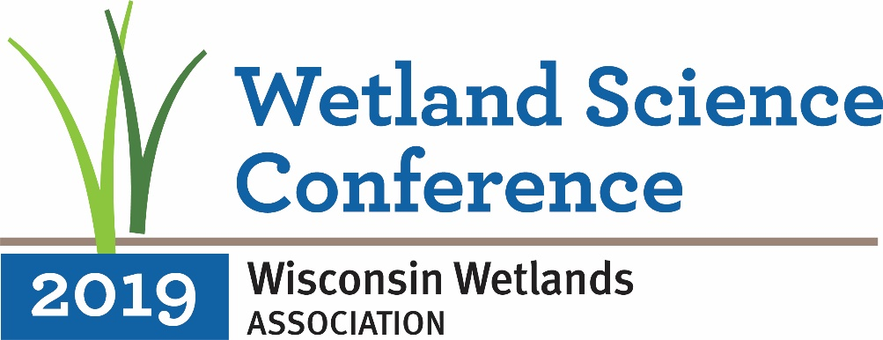

CALL FOR SYMPOSIA Symposium Proposals Deadline: September 28, 2018

Wisconsin Wetlands Association invites you to submit a proposal for a Symposium at our 24th annual Wetland Science Conference, to be held February 19-21, 2019, in Madison, WI.

We seek proposals for half-day or full-day symposia, which could include oral presentations, panel discussions, and/or open discussion. All symposia should further information-sharing and collaboration on current critical wetland issues.

Symposia are planned sessions on special topics that support the conference theme and that integrate across disciplines and across the landscape. Symposia organizers will be responsible for recruiting speakers for timeslots in multiples of 20 minutes (20, 40, 60, etc.), including time for questions and discussion. The Conference Advisory Panel Symposium Committee welcomes interested persons to organize symposia on subjects relevant to Wisconsin wetlands; the list below provides some possible topic areas.

The conference will highlight the environmental, socio-cultural, and economic value of wetlands and will promote the latest research on and techniques for wetland and watershed planning, restoration, and management.

SYMPOSIA PROPOSALS
Individuals considering submitting a symposium proposal are strongly encouraged to contact Katie Beilfuss, WWA Outreach Programs Director, at 608-250-9971, prior to submitting to discuss ideas and process.

Symposium proposals are due by September 28, 2018. Please email your proposal to programs@wisconsinwetlands.org. Microsoft Word or Adobe PDF documents only, please. The Conference Advisory Panel Symposium Committee will make final decisions regarding symposia this fall. Due to limited program space and time, the final list of symposia will be constrained (we expect to offer 1-3 symposia, depending on the length of each).
Important Dates
- Symposium proposals due: September 28, 2018
- Decisions on symposium proposals: November 1, 2018
- Presenters for accepted symposia submit abstracts: November 15, 2018
- Symposium details posted on conference website: December 23, 2018

See following pages for suggested symposia topics and information on submission evaluation process & criteria and organizer responsibilities.
Wisconsin Wetlands Association 2019 Call for Symposia

SUGGESTIONS FOR SYMPOSIUM TOPICS
Climate Adaptation
- The role of wetlands in the global carbon cycle
- Climate change impacts and adaptations: how are wetlands part of the solution?
- Vulnerabilities of wetlands to climate change and predicted impacts to Wisconsin wetlands
Wetlands and Biodiversity Conservation
- Wetland wildlife every wetland enthusiast should know
- Taking inventory of wetland diversity: what have we learned?
- Wetland wildlife monitoring: programs and results
- Effects of management on species abundance and diversity
Wetlands & Water Quality
- The role of wetlands in improving water quality
- Wetlands as a tool for reaching Area of Concern and TMDL goals
Wetland Restoration & Management
- Wetlands in an agricultural landscape: Helping achieve on-farm and watershed goals
- Wetland restoration science: What have we learned? Where are we headed?
- Wetland management science: What have we learned? Where are we headed?
- Fire as a wetland management tool
- Determining historic wetland site conditions: How do we set our restoration goals?
- Wetland mitigation: policies and practices
Watershed Assessment & Planning
- Incorporating wetland science into community land use planning
- Applications of wetland assessment for community planning and decision-making
Wetland Functions & Services
- Impacts of invasive plants on wetland communities
- Measuring wetland functions: what have we learned?
- Economic valuation of wetland resources in Wisconsin: Case Studies
- The role of wetlands in watershed hydrology
- The role of wetlands in riparian systems
Communicating About Wetland Science
- Translating wetland science for the public: How can we be effective doing this?
- How have advancements in wetland science changed the practices of professionals? (e.g. in the work of professional communities in energy, construction, water treatment, planning, etc.)

To have your Symposium Proposal considered for WWA’s
24th annual Wetland Science Conference,
please complete the symposium proposal submission form
available at http://conference.wisconsinwetlands.org/

Wisconsin Wetlands Association 2019 Call for Symposia
1. Evaluation Process and Criteria
The Conference Advisory Panel Symposium Committee will make the final decision with regard to the acceptance and scheduling of all symposia. Proposals will be reviewed following the submission deadline, and acceptance notices will be sent as soon as possible in order to allow organizers sufficient time to coordinate with speakers, make travel arrangements, seek institutional support, and secure sponsorship as necessary. Proposals will be evaluated based on the following criteria:
- scientific merit, with emphasis on new research results, cutting-edge developments, novel perspectives, and innovative or interdisciplinary approaches
- clear relevance to the field of wetland research, restoration, and management and its social, economic and/or ecological aspects.
- applicability to wetland restoration or management practices and/or policy
- availability of funding to support speaker attendance (and/or travel). WWA is not able to support symposium speaker registration or travel costs.
- submission of a clearly written and compelling proposal that includes a draft program for the symposium session.
Organizers will be notified electronically concerning the receipt, review, and acceptance of their proposal via the e-mail address provided. Organizers will be notified as to the acceptance of their proposal no later than November 1, 2018. If for some reason you do not hear from the Conference Advisory Panel Symposium Committee by this date, please contact Katie Beilfuss, WWA Outreach Programs Director (programs@wisconsinwetlands.org).
2. Organizer Responsibilities
All sessions must have a lead organizer who serves as the primary point of contact. This person should be readily available by email in the months leading up to the conference and is expected to be present at the symposium, workshop, or training course.
Funding: WWA will provide meeting space and onsite logistical support for all symposia but is not able to offer any travel or accommodation assistance, honoraria, complimentary registration, or other funding to session organizers or individual speakers/presenters. WWA encourages prospective organizers to seek sponsorships and/or institutional support to help offset the costs associated with their symposium and we are happy to collaborate on these efforts.
If Your Proposal Is Accepted: Organizers are responsible for ensuring that all presenters taking part in their symposium submit an abstract by November 15, 2018, via the online abstract submission system used by all presenters for the conference. Details about how to access this system will be sent to organizers of accepted symposia upon notification of acceptance. Presenters must also register for the conference before the deadline for registration, which will be posted later this fall. Presenters who do not meet these deadlines may be excluded from the conference program. Symposium organizers must also submit an abstract as above if they plan to give a presentation during their session and would like their abstract included in the abstracts booklet.
If you are unable to secure enough presenters to complete your symposium or to take the place of any presenters who have cancelled, the Conference Advisory Panel Symposium Committee will work with you to determine the best remedy so as to maintain the program’s integrity.

