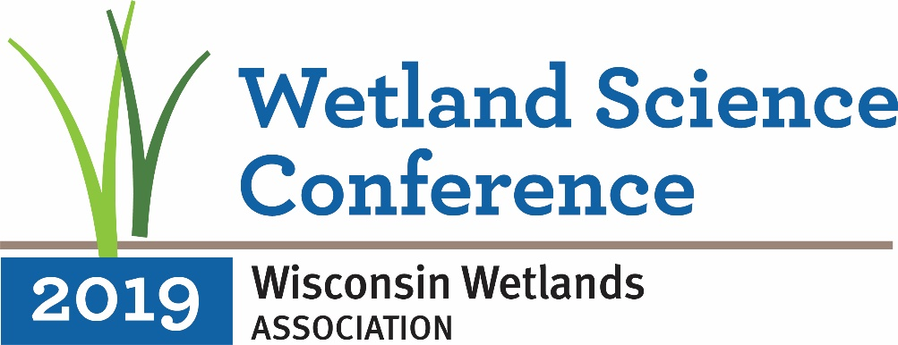

CALL FOR WORKSHOPS
Proposal Deadline: September 28, 2018

Wisconsin Wetlands Association invites you to submit a proposal for a Workshop at our 24th annual Wetland Science Conference, to be held February 19-21, 2019, in Madison, WI. The conference will highlight the environmental, socio-cultural, and economic value of wetlands and will promote the latest research on and techniques for wetland and watershed planning, restoration, and management.

Workshops offer opportunities for participants to learn and apply new skills and methodologies. Workshops can range from a couple of hours to a half or full day, and they can be held on the day prior to the conference, the afternoon of day 2 of the conference, or on the day following the conference. All workshops should further knowledge-building on topics related to wetland science, management, and communications. Workshop organizers will be responsible for recruiting instructors and facilitators for their session.

Individuals considering submitting a workshop proposal should contact Katie Beilfuss, WWA Outreach Programs Director, at 608-250-9971, prior to submitting to discuss ideas and process.

KEY DATES
- Proposals due: September 28, 2018
- Proposal status notification: November 5, 2018
- Conference dates: February 19-21, 2019

SUBMISSION
Workshop proposals should be submitted by email in Microsoft Word or PDF format only. Please email your proposal to programs@wisconsinwetlands.org. Proposals should be limited to two pages, single spaced (not including biographical sketches) and include the following information:
- Proposed title
- Organizers (names, affiliations, email, identify one primary contact person)
- Description of workshop: objectives (at least 3), goals, and expected outcomes
- Statement regarding how the workshop can benefit attendees and the wetland community
- Description of target audience and estimated number of participants (minimum and maximum)
- Proposed workshop duration, format, activities, and schedule
- Any special A/V needs
- Any costs that would need to be covered by a fee charged to be charged to workshop registrants
- Short biographical sketch for each presenter/instructor, describing relevant experience and qualifications (not included in page limit)

REVIEW CRITERIA
Proposals will be evaluated by members of the Conference Advisory Panel based on the following criteria:
- Relevance to conference vision/topics and attendees
- Potential to bring in participants to the conference from different audiences
- Overall quality of submission
- Provides a hands-on, collaborative, and/or active learning environment for attendees

POSSIBLE WORKSHOP TOPICS
- Wetland plant identification
- Techniques for effectively communicating wetland science to non-science audiences
- Demonstration of new tool / product of interest to wetland professionals (e.g., drones for surveys and management assessment; hardware/software for field data collection and management; products for protecting wetlands from damage during construction)

OTHER DETAILS
Organizer Responsibilities
All workshops must have a lead organizer who serves as the primary point of contact. This person should be readily available by email in the months leading up to the conference and is expected to be present at the workshop. Organizers are responsible for ensuring that all instructors/facilitators taking part in their workshop register for the conference before the deadline for registration (noon on February 14, 2019). Reduced early bird rates are available through January 18, 2019.
Covering Costs: WWA can provide meeting space and onsite logistical support for workshops. We can charge a special fee to anyone registering for your workshop to cover any workshop costs (e.g. instructor payments, conference registration, supplies, catering, special AV equipment), however we are not able to offer any complimentary registration, travel or accommodation assistance, honoraria, or other funding to session organizers or instructors except through these workshop fees.

To have your workshop proposal considered for WWA’s
24th annual Wetland Science Conference,
please complete the workshop proposal submission form
available at http://conference.wisconsinwetlands.org

